Buffet Style Menu

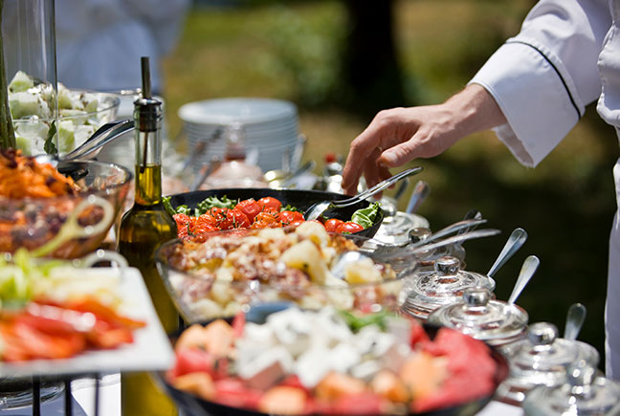
All buffets have a 10-person minimum |

Buffets include but are not limited to:
Salad | Entre | Dessert
Add on appetizers and charcuterie to meet your needs.

There are so many ways to customize your celebration, choose from any of these customer favorites or let us design a unique menu to match the theme and vision of your event. You dream it and we will deliver it!

In order to guarantee quality & freshness, all orders must be finalized no later than 72 business hours prior to event. Thank you.

Salad Bar
Mixed Green
Spinach
Grilled Chicken
Chopped Bacon
Carrots
Cherry Tomato
Cheddar Cheese
Feta Cheese
Broccoli Florets
Cucumber
Red Onions
Chickpeas
Mild Peppers
Mushrooms
Herb Croutons

DRESSINGS
Ranch & Balsamic Vinaigrette
Can Customize on Requests

MAIN COURSE
STARCH
Potato / Rice / Pasta / | created with love
PROTEIN - gf + df
Beef / Chicken / Pork / | daily creation
** Seafood is available upon request at market price **
GRILLED MARKET VEGGIES - gf + Vegan
Seasonal Vegetables

DESSERTS
Chefs Choice

